TIS - Computer Operations Procedures Template
Originator: | Jason Malveaux |  | Effective Date: | August 1, 2019
Manager Approval: | Sender De La Roca |  | Original Date: | August 1, 2019
 |  |  | Revision Date: | May 10,2025
PURPOSE
The purpose of this procedure is to establish a standardized and efficient process for managing tape and backup operations within the Los Angeles County Office of Education (LACOE). This procedure aims to ensure the integrity, security, and availability of critical data by outlining the steps for proper handling, storage, and retrieval of backup tapes. It also aims to minimize data loss and downtime by providing clear guidelines for regular backup schedules, verification processes, and disaster recovery protocols. By adhering to this procedure, LACOE will enhance its data protection measures, support compliance with regulatory requirements, and maintain the continuity of educational and administrative services.
PROCEDURES

TAPE

and

BACKUP PROCESSING

at
LACOE

OVERVIEW………………………………………………………………………………………………………
TAPE 1
and 1
BACKUP PROCESSING 1
at 1
CONTAINER RETENTION 4
Transport Containers 4
Storage Containers 4
IRON MOUNTAIN 5
Security 5
SecureSync 5
Navigating SecureSync 5
Login 5
Securing your personal information 6
Iron Mountain Deliveries 10
Iron Mountain Pickups 10
OPEN MEDIA PROCESSING 10
Transport Container Note 10
Scanning Open Media 10
Open Media Jobs 16
OFFSITEH 16
Open Systems BEST and ECS 17
CLOSED CONTAINER PROCESSING 19
Scanning IBM Closed Container Media 19
Creating the Container Pickup Manifest 21
Saving the report in the date-appropriate folder on the J:\ drive 24
CLOSED CONTAINER JOBS 25
OFFSITED & OFFSITEW 25
PBX – The Phone System Backup 26
QNAP – RAD Disk Array ( Fridays ) ECS and ERP teams 27
Special processing 28
Weekly Requests for Tape Return 28
Monthly Requests for Tape Return 29
Special Requests 30
Add-ons 30
Emergency 30
Appendix A. Requests to Deliver Media 31
Identify the media 31
Login to Iron Mountain 31
Request delivery 31
“NOT AT IRON MOUNTAIN” message 31
AT LACOE 31
Server backups 31
IBM tapes 32
In Transit 32
Download Iron Mountain inventory of Open Media 32
In a Locked Container 32

OVERVIEW

The Sun/Oracle SL3000 tape silo in the tape library does all the tape handling chores for mainframe JOBs here at LACOE. When a JOB writes a data set to tape rather than DASD, a tape drive is automatically selected and a tape mounted. When an existing tape data set is required, that tape is mounted without the need for any operator intervention.

Daily and weekly backups of critical data are taken and sent offsite to Iron Mountain in the event they are needed for disaster recovery.

Iron Mountain is LACOE’s records management and data protection vendor.

Before each mainframe batch cycle – to capture the day’s online processing – and after each night’s processing, a backup is taken. Tape copies of these backups are ejected in the morning by the daily OFFSITED job. The tapes are placed in closed containers and sent to offsite storage at Iron Mountain for 21 days.

The weekly OFFSITEW job is similar in function. It takes a more complete backup which includes the TEST environments. These tapes are also sent to offsite storage at Iron Mountain for 21 days.

$AVERS is software that archives the SYSOUT created by users, system and production jobs. After seven days on DASD, $AVERS archives the SYSOUT. A tape copy of this archive is ejected by OFFSITEH and sent to Iron Mountain as Open Media.

HSM, IBM’s Hierarchical Storage Manager, backs up selected data. Copies of these backups are written to tape. They are ejected by OFFSITEH and sent to Iron Mountain as Open Media.

$AVERS and HSM use compression algorithms that allow their backup tapes to be used very efficiently. As data on these tapes is replaced by successive iterations of backups, the tapes containing duplicated or outmoded data are returned to the LACOE tape library. Because of this, these tapes are not held in containers for a specific length of time; instead, they are stored individually at Iron Mountain as Open Media with an indefinite retention date.

On a weekly and monthly basis Technical Services supplies Data Control with a list of $AVERS and HSM tapes to be returned to the tape library. If needed, they can be recalled at any time. Recalled tapes are immediately returned to the silo for use.

Server backup tapes for BEST and Enterprise Computer Systems (ECS) have different formats than mainframe tapes. They are sent offsite to Iron Mountain for Disaster Recovery purposes as Open Media with a definite retention date.

CONTAINER RETENTION
Iron Mountain supplies LACOE with containers for two different purposes:

Transport Containers
Transport containers are used for the temporary storage of Open Media. These containers are only used to move Open Media tape volumes from LACOE to the Iron Mountain facility. When these containers reach Iron Mountain, their contents are removed immediately and hung on racks for individual recall.

These containers are usually blue or black plastic boxes with different inserts for IBM and Server backup tape volumes.

All Transport Containers have serial numbers beginning with “TR”. Containers waiting to be used are stored under the table on the right side of the picture below.

Storage Containers
Daily and Weekly IBM backups are placed in storage containers. These containers stay closed and locked for the entire time they are offsite. Containers waiting to be used are stored under the table on the left. Locks are stored in the center drawer of the table in the picture below.

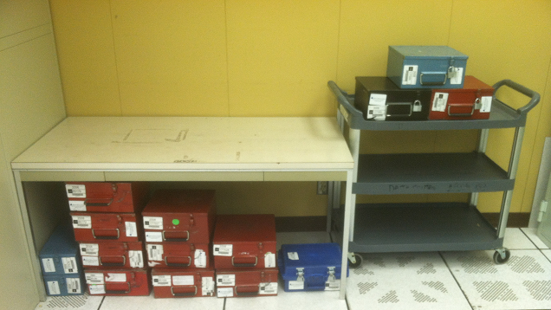
Transport
Containers
here
Locks in Drawer
Storage
Containers
here
Locked
Outgoing
Containers
Here

These containers are a mix of red, blue, and black boxes as well as the blue containers.

IRON MOUNTAIN
Iron Mountain is LACOE’s records management and data protection vendor.

Security
All full time LACOE Computer Operators and Data Control personnel have been issued an Iron Mountain user ID and Authorization number. Your PIN number is the first 4 digits of your Iron Mountain Authorization number. If you do not know your ID, your shift supervisor can provide your Iron Mountain user ID and reset your password. You will receive an email with your UID and a password good for 90 days. You can then LOGON to SecureSync and retrieve your PIN.

SecureSync
https://loginciam.ironmountain.com is the default home page for Internet Explorer on the PC in the computer library. Authorized users can Login to this URL from work stations in Data control, Operations, and the Tape Library.

Navigating SecureSync

Login
Enter your SecureSync password
Enter your SecureSync user ID

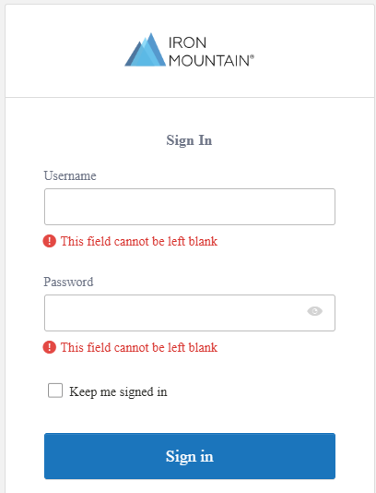

Securing your personal information

After Login the following screen is presented for your Multi – Factor Authentication window
The SMS code will be send to your cell phone if that is the option or it may ask for specific question you have set up with Iron Mountain.

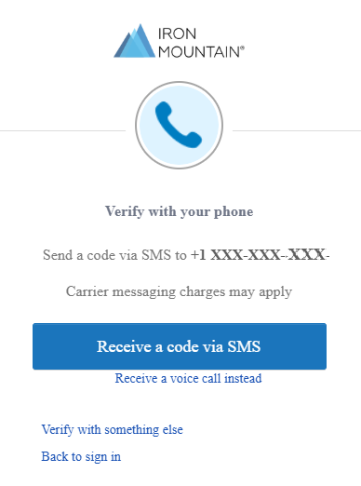 | 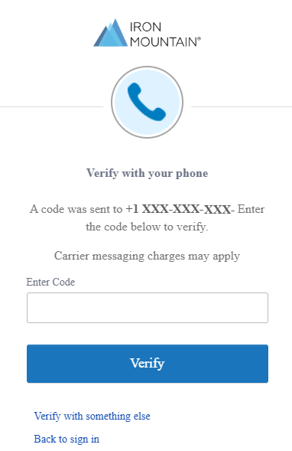

Logon to SecureSync

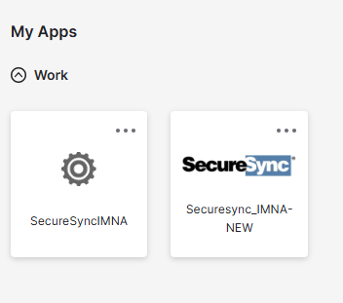

Choose Administration

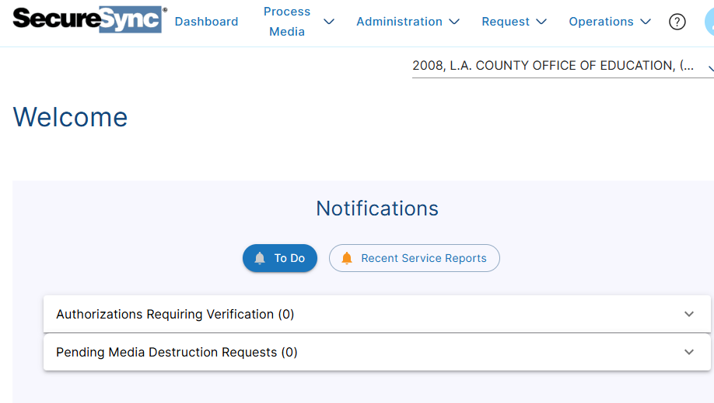
Choose
Admin

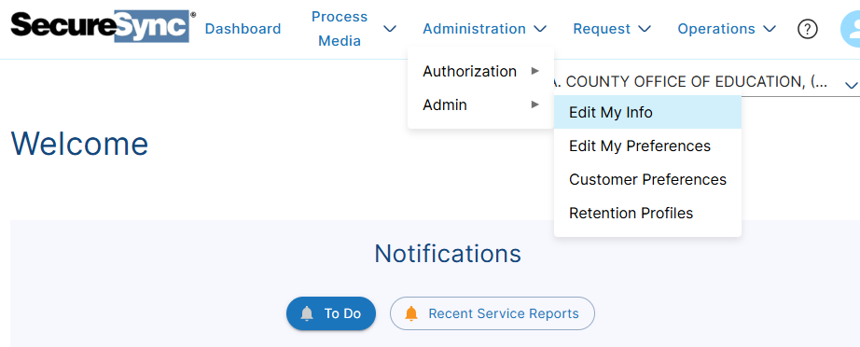

Click on Edit My Info to see your SecureSync Authorization and PIN numbers or Change Password
to reset your password. The picture below shows an old menu display for security purposes. The screen that you will see will have the same information as the one shown below.

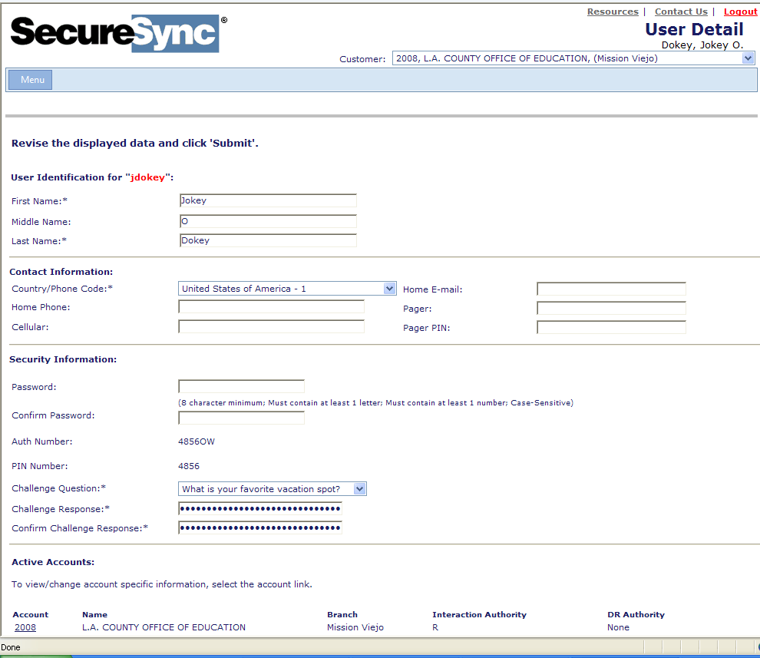
Pin number
Authorization
Number

Processing Media

When Process Media is chosen the following is displayed:

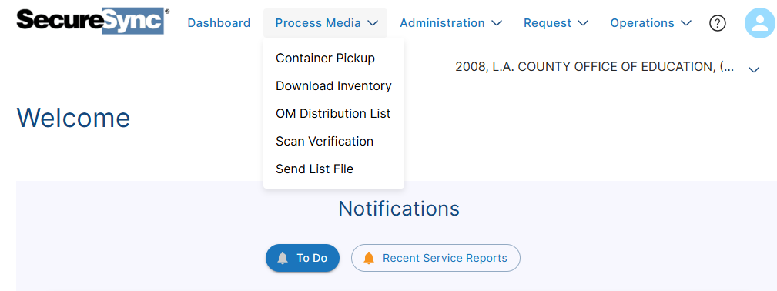

Choose Container Pickup to process the following:

- OFFSITED
- OFFSITEW

Choose OM Distribution List to process:

- OFFSITEH
- Open Systems tape backups for BEST or ECS

Go to CLOSED CONTAINER PROCESSING or OPEN MEDIA PROCESSING in this document for further instructions.

Iron Mountain Deliveries
Deliveries from Iron Mountain usually arrive between 11:30 and 14:30, Monday through Saturday. An individual from Operations or Data Control MUST be present to verify Iron Mountain’s delivery by entering his or her Iron Mountain PIN code on the Iron Mountain scanner used by the pickup driver.

Iron Mountain Pickups
At pickup time, the Iron Mountain driver will scan all the containers that will be taken to Iron Mountain and he will sign one copy of the Container Pickup Report. This must be a copy of the Total ContainerPickupManifest.pdf. that references ALL the containers – including the Transport Containers.

The signed copy is placed in the Tape desk tray stack on the shelves to the west of the entrance to Data Control.

OPEN MEDIA PROCESSING

Transport Container Note
Inserts in the large Transport containers come in 2 types:
- 20 slots for IBM format tapes
- 16 slots for LTO server tapes in plastic boxes
When sending server tapes in plastic boxes to Iron Mountain, use the 16-slot inserts. If 16-slot inserts are not available, remove the insert completely. Foam padding is available if necessary.

Scanning Open Media
Login to the Iron Mountain URL: https://loginciam.ironmountain.com, select Process Media and then OM Distribution List.

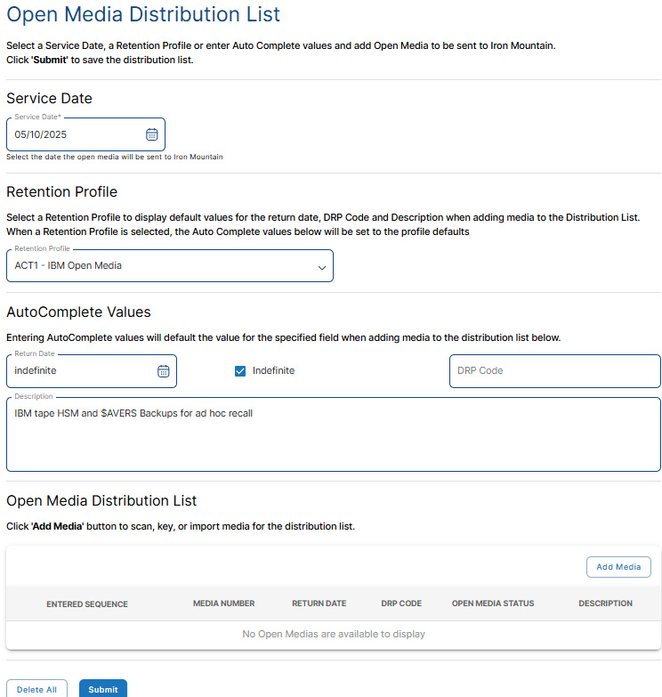
Select one of these Retention Profiles. 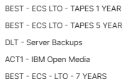
Select a Service Date
Usually today
Click here for a screen to add the tape volume serial numbers

After these steps and clicking on Add Media, the following screen will be displayed:

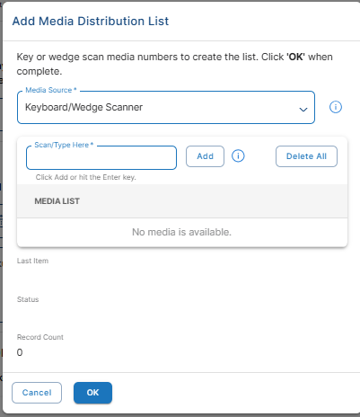
Click here to scan the tapes.
The volume serial numbers will appear here.
The number of tapes you have scanned appears here.
Click OK when you have scanned all the tapes in the container.

You can also opt to upload a .TXT file instead of scanning tapes. The tape list will be provided by the OFFSITEH job and can be save in the \\lacoe-fsvr\Operations\Comp_Ops\Data_Control folder.
The next screen is an example of what will be presented when you click OK. The next screen will show you how the screen will look if you upload a .TXT file:

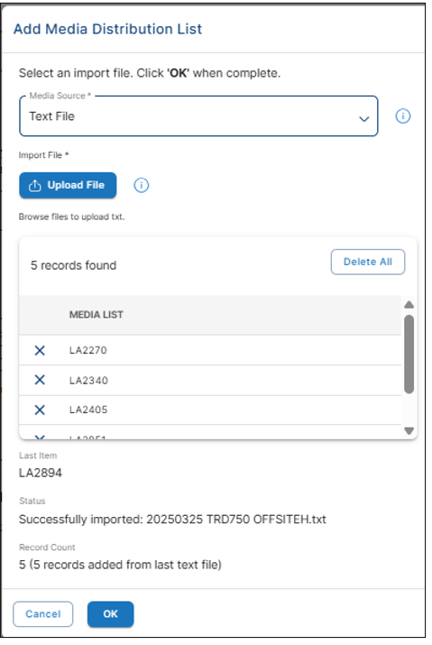

Then click on OK , Submit and Prepare report at the bottom of the screen

This screen is an example of Open Media processing for the Mainframe OFFSITEH job. You can see that it presents the volume serial number, Return Date and a description of the tape from the Retention Profile.
Click
Prepare
Report
Click Submit.

On the screen that follows, click Prepare Report.
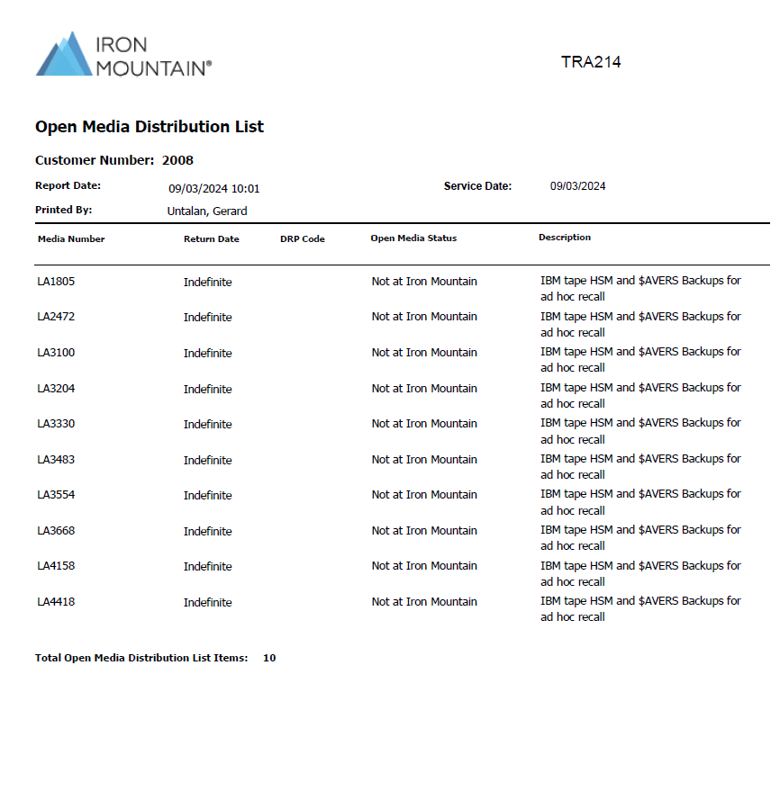

Print 2 copies of the Open Media Distribution List.

Save a copy of the report in the date-appropriate folder on the Comp_Ops\Data_Control - shared folder.

\\lacoe-fsvr\Operations\Comp_Ops\Data_Control is mapped to the J:\ drive for most workstations in Data Control and the Tape Library. If there is a problem see the Shift Supervisor for help in mapping the drive. In J:\TAPE_DATA there is a folder for each month of the year. Folder names have the following format: YYYYMM MMM, four digit year, two digit month, and three letter month, e.g. for April 2024, the folder is: J:\Tape_Data\202404 APR.

Code the filenames as follows: YYYYMMDD ContainerSerialNumber meaningful report name, e.g. on April 21, 2024 the file name for Transport Container TRA214 would be:
20240421 TRA214 OFFSITEH.

Print 2 copies of the Open Media Distribution List.

Write serial number of the TR container on the Open Media Distribution List.

Place one copy of the Open Media Distribution List in the transport container. The 2nd copy goes in the desk tray stack in Data Control with the Container Pickup reports. If there is any miscellaneous paperwork, it should be attached.

NOTE:
This creating-the-report process needs to be repeated for each different type of server backup. The report detailing each set of tapes MUST be placed in the same container as the tapes. It’s OK to put more than one set of Open Media backups in the same Transport Container, but the report must be in the same container as the referenced tapes..

Open Media Jobs

OFFSITEH
OFFSITEH ejects HSM and $AVERS backup tapes from the silo shortly after 23:00 (11 PM), Tuesday through Saturday. Operations personnel put these tapes in Transport containers with a container serial number beginning with the letters ‘TR’. These are OPEN MEDIA tape volumes. As soon as the Transport containers reach Iron Mountain, the tape volumes are removed from the Transport containers and placed in racks so they can be tracked and recalled individually as needed.

Data Control personnel sign on to the Iron Mountain URL: https://loginciam.ironmountain.com, select Process Media and then OM Distribution List from the drop-down menu.

Refer to the Scanning Open Media instructions above.

The Service Date will be the next pickup date. The Retention Profile will be ACT1 – IBM Open Media. These tape volumes have an indefinite retention date.

Clicking on Add Media to Distribution List brings up the screen that allows the tape volumes to be scanned. The Media Source is Keyboard/Wedge Scanner. Using the hand scanner, scan the volumes and click OK. The second option is to upload a .TXT file. You can use this option as well.

On the next screen click Submit. On the screen that follows that, click the Prepare Report box to create the Open Media Distribution List.

Print 2 copies of the Open Media Distribution List and save a copy of the report in the date-appropriate folder in J:\Tape_Data.

Code the filenames as follows: YYYYMMDD ContainerSerialNumber meaningful report name, e.g. on April 21, 2024 the file name for Transport Container TRA214 would be:
20240421 TRA214 OFFSITEH.

Write serial number of the TR container on each copy of the Open Media Distribution List.

Place one copy of the Open Media Distribution List in the transport container. The 2nd copy goes in the desk tray stack in Data Control marked Tapes Out. If there is any miscellaneous paperwork, it should be attached.

The Iron Mountain pickup driver will scan the barcode on all containers and sign the TOTAL ContainerPickupManifest which will contain the serial numbers of ALL the containers being picked up.
An individual from Operations or Data Control must be present to verify Iron Mountain’s pickup on the Iron Mountain scanner used by the pickup driver.

When IBM Open media tapes return, they are placed in the silo immediately.

Open Systems BEST and ECS

Server backup tapes are delivered to Data Control by different server groups. Server LTO backup tapes must have their own plastic boxes before they go into the transport containers for Iron mountain.

The Retention Profile will be different depending on the request from the server team. If requested by owner, the retention dates can be modified as requested. Put these tapes in blue or black Transport containers with a serial number beginning with the letters ‘TR’.

Retentions profiles:

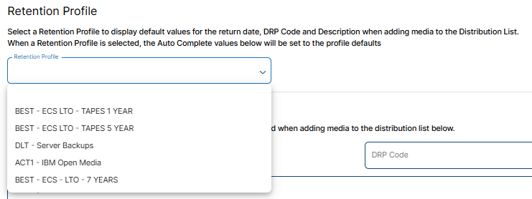

Data Control personnel sign on to the Iron Mountain URL: https://loginciam.ironmountain.com, select Process Media and then OM Distribution List from the drop-down menu.

Refer to the Scanning Open Media instructions above.

The Service Date will be the current date. The requested Retention Profile will selected.

Clicking on Add Media to Distribution List brings up a screen allowing the tape volumes to be scanned. The Media Source is Keyboard/Wedge Scanner. Using the hand scanner, scan the volumes and click OK. The second option is to upload a .TXT file. You can use this option as well.

On the next screen click Submit. On the screen that follows that, click the Prepare Report box to create the Open Media Distribution List.

Print 2 copies of the Open Media Distribution List.

Save a copy of the report in the date-appropriate folder on the Comp_Ops\Data_Control - shared folder.

Code the filenames as follows: YYYYMMDD ContainerSerialNumber meaningful report name, e.g. on April 21, 2024 the file name for Transport Container TRA214 would be:
20240421 TRA214 BEST ECS.pdf.

Place one copy of the Open Media Distribution List in the transport container. The 2nd copy goes in the desk tray stack in Data Control with the Container Pickup reports. If there is any miscellaneous paperwork, it should be attached.

The Iron Mountain pickup driver will scan the barcode on all transport containers and sign the TOTAL ContainerPickupManifest which will contain the serial numbers of ALL the containers being picked up.
An individual from Operations or Data Control must be present to verify Iron Mountain’s pickup on the Iron Mountain scanner used by the pickup driver.

CLOSED CONTAINER PROCESSING

Scanning IBM Closed Container Media
Login to the Iron Mountain URL: https://loginciam.ironmountain.com, select Process Media and then Container Pickup.

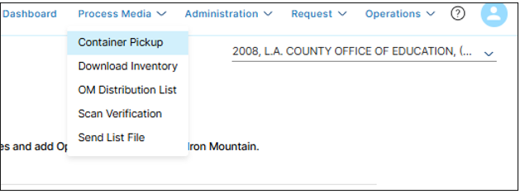

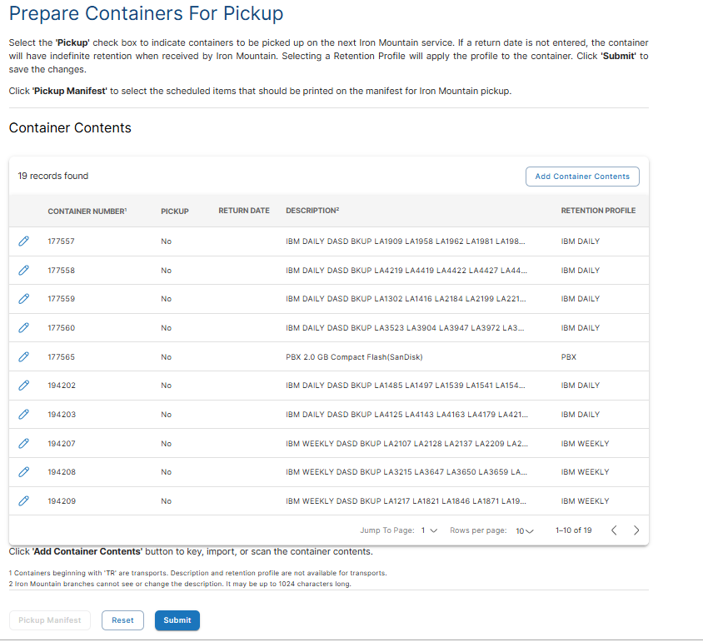

Search for the container that is going to be sent to Iron Mountain from the list above. Once found, click on the pencil to select the container. The next window will appear and here you will click on the pickup button and the Return Date will populate. Select the Retention Profile and in the Description box below the prepopulated text, type or Copy and paste the tapes from the OFFSITE job which are going into this container.

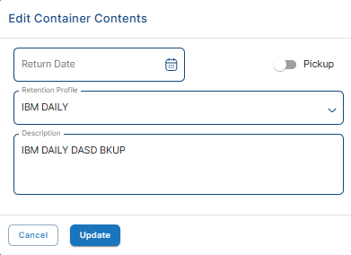
Select the Retention Profile for the tapes
Toggle this to the right by clicking on the button

The OFFSITE job will have the list of the tapes you will enter in the description. Example:

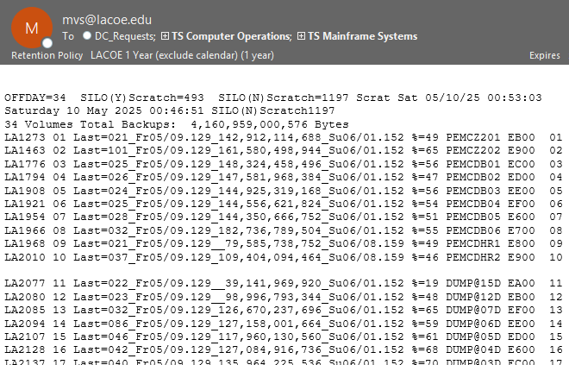

If there are more than 20 tape volumes, Operations will have to use one or more additional containers. For each container, select a Retention Profile of IBM Daily or IBM Weekly. If there are tape volume serial numbers that remain in the container Description listing from its previous use erase them and place the cursor in the now-empty Description box. Enter the tape volume serial numbers.

Once all Closed Containers are completed and selected along with the Open Containers a pickup manifest needs to be created.

Creating the Container Pickup Manifest

After scanning all the tape volumes in all the containers, check to make sure that any ‘TR’ containers previously processed for Open Media are checked on this screen. Then click on SUBMIT at the bottom of the page.
Under the PICKUP column all containers going out should be marked as yes
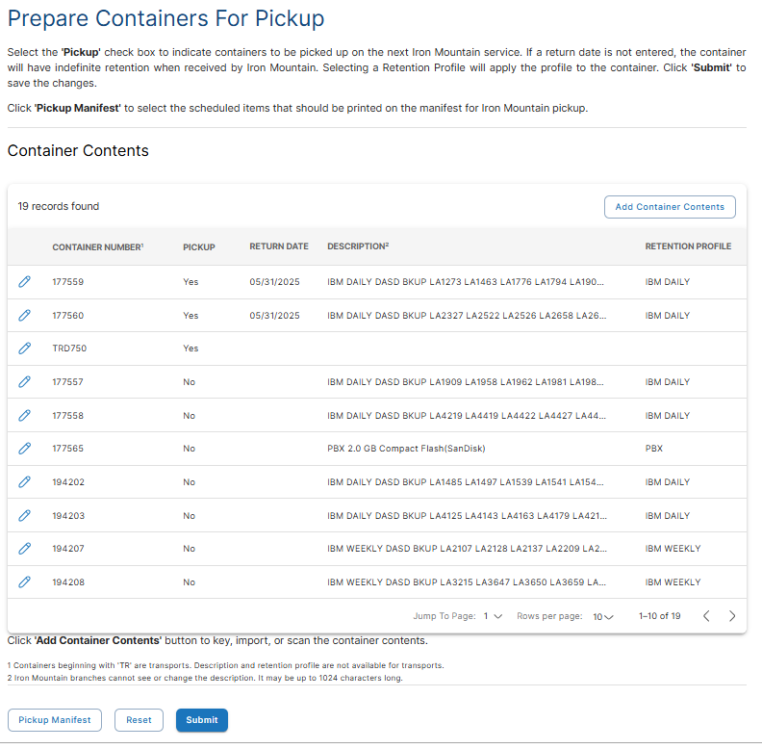
Click on Submit at the bottom of the page.
Last on this page is to Click on Pickup Manifest.

When the screen comes back, Click Prepare Pickup Manifest on the screen that comes up.

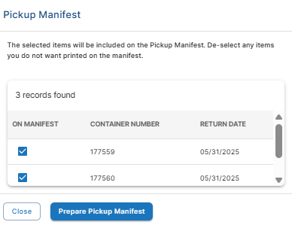
Make sure that all the container going out match the records found here
Click Prepare Pickup Manifest

NOTE:
The above screen should include any previously prepared Open Media containers as well as the IBM Closed Containers just processed. This will bring up the Container Pickup Manifest .pdf file as shown on the next page.

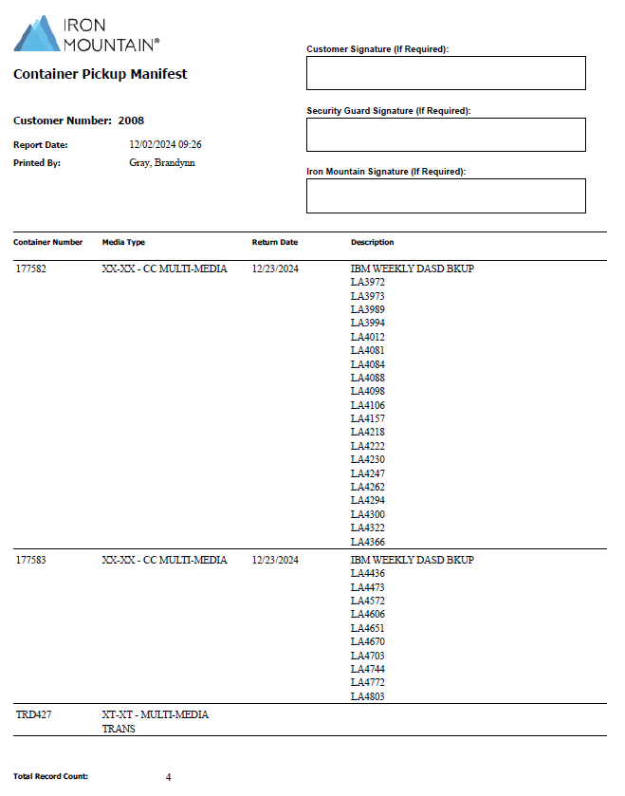
Contents of the just-scanned Closed Containers
Previously created Open Media Container

A copy of the Container Pickup Manifest must be placed in each of the Closed Containers to facilitate Disaster Recovery. Print as many copies as needed for the Closed Containers plus 1:
- One copy to be signed by the Iron Mountain pickup driver
Save a copy of the report in the date-appropriate folder on the J:\ drive as YYYYMMDD meaningful report name, e.g. 20240420 TOTAL ContainerPickupManifest

The container serial numbers for ALL the containers being picked up by Iron Mountain – not only the Closed Containers for OFFSITED and OFFSITEW, but also the serial numbers of the containers being picked up that contain server backups – MUST appear on the TOTAL Container Pickup Report.

At pickup time, Iron Mountain personnel sign one copy of this report. The signed copy is placed in the desk tray stack in Data Control with the Container Pickup reports.

Saving the report in the date-appropriate folder on the J:\ drive

\\lacoe-fsvr\Operations\Comp_Ops\Data_Control is mapped to the J:\ drive for most workstations in Data Control and the Tape Library. If there is a problem see the Shift Supervisor for help in mapping the drive. In J:\TAPE_DATA there is a folder for each month of the year. Folder names have the following format: YYYYMM MMM, four digit year, two digit month, and three letter month, e.g. for April 2021, the folder is: J:\Tape_Data\202104 APR.

Code the filenames as follows: YYYYMMDD ContainerSerialNumber meaningful report name, e.g. on April 20, 2024 the file name for Transport Container TRA214 would be:
20240421 TRA214 OFFSITEH.

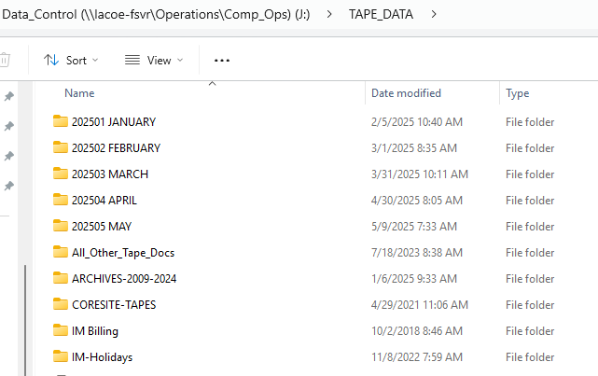

Store the generated reports in the appropriate time-related folder.

CLOSED CONTAINER JOBS

OFFSITED & OFFSITEW
These jobs both eject IBM tapes. OFFSITED ejects tapes on a Daily basis – Tuesday through Saturday. OFFSITEW ejects tapes once a week on Monday morning. Operations personnel put the tapes in containers with the printout from the mainframe job that specifies the number of tapes and their volume serial numbers. These containers are locked after being scanned by Data Control personnel and remain locked for the whole time they are offsite at Iron Mountain.

Login to the Iron Mountain URL: https://loginciam.ironmountain.com, select Process Media and then Container Pickup.

GOTO Scanning IBM Closed Container Media for detailed instructions.

If there are more than 20 tape volumes, Operations will have used one or more additional containers. For each container, select a Retention Profile of IBM Daily or IBM Weekly, erase the tape volume serial numbers that remain in the container listing from its previous use, place the cursor in the now-empty box, and scan the tape volume serial numbers.

PBX – The Phone System Backup

(This procedure is no longer applicable since we moved to ZOOM phones. We keep this procedure here because we will still keep the last copy of the Ericson’s data base at Iron Mountain.)

This is a backup to a 2.0 GB Compact Flash drive rather than a backup to tape. The flash drive is delivered to Data Control on a monthly basis. It is signed in by Data Control personnel on the Media Backup Log and placed in an envelope in a Closed Container – NOT a transport (TR) container. The Closed Container is locked and remains locked for the time it is offsite. No other media will be included in this Closed Container.

Data Control personnel sign on to the Iron Mountain URL: https://loginciam.ironmountain.com, select Process Media and then Container Pickup from the drop-down menu.

Select the container number into which the flash drive is to be placed. Any tape volume serial numbers that remain in the container listing from its previous use are erased, and a Retention Profile of PBX is chosen. The PBX Retention Profile has an indefinite return date. There is no scan because there is no serial number available.

Ensure that the Closed Container number is added to the TOTAL ContainerPickupManifest.pdf.

On a monthly basis, TS TELEPHONE SERVICES will bring an updated flash drive to Data Control for storage at Iron Mountain. Data Control will include the updated drive in the daily pickup and request the return of the currently stored flash drive from Iron Mountain.

When the container with the flash drive is returned from Iron Mountain, the envelope containing the drive is placed in the inbox of the Data Control Shift Supervisor, and a notification email is sent to TS Telephone Services, Antonio Ocampo, DC_Requests and the Operations shift Supervisor.

TS TELEPHONE SERVICES will sign for the incoming drive on the Media Backup Log when they pick it up.

QNAP – RAD Disk Array ( Fridays ) ECS and ERP teams

(This procedure is no longer applicable since we the ECS and ERP team are now mirroring data to our Colocation at CoreSite soon to be Pomona. This procedure will be removed once we are fully stablished at Pomona Colocation)

This is a backup to a disk array rather than a backup to tape. This device is stored at Iron Mountain in a Closed Container. Every Friday ERP personnel bring the device to the Tape Library and place it in one of the large DP containers. The ECS team does this on the last Friday of every month.
Data Control personnel make sure that the device is protected against shock using available polyethylene padding.

Data Control personnel sign on to the Iron Mountain URL: https://loginciam.ironmountain.com, select Process Media and then Container Pickup from the drop-down menu.

Select the container number into which the device has been placed. Any tape volume serial numbers that remain in the container listing from its previous use are erased, and a Retention Profile of RAD Disk Array is chosen. There is no scan because there is no serial number available.

Ensure that the Closed Container number is added to the TOTAL ContainerPickupManifest.pdf.

When Iron Mountain makes their delivery on Friday, it will include the returning QNAP device(s). Email TS Enterprise Computing Services and/or TISPlatform-ERP to alert them of the delivery. Each team’s personnel will pick up the returned device from the Tape Library.

Special processing

Weekly Requests for Tape Return
Each Thursday at 14:00, DC_Requests receives an email from mvs@lacoe.edu entitled (PHSMW099) Bi-weekly HSM Scratch Tape Return List. This email has a text file attached that contains a list of IBM Open Media tape volumes that can be returned to LACOE from Iron Mountain. These can be recalled as needed since they will be scratch tapes upon arrival and inserted back into the Silo. There is no need to recall them right away.

If we need extra scratch, we can recall these tapes with this procedure:

Save the file to \\lacoe-fsvr\Operations\Comp_Ops\Data_Control\Tape_Data (Data Control clerks J: Drive) with the name format like “yyyymmdd BI-WEEKLY HSM SAVRS SRATCH TAPE LIST.txt e.g., 20210406 BI-WEEKLY HSM SAVRS SRATCH TAPE LIST.txt.

Sign on to the Iron Mountain URL: https://loginciam.ironmountain.com, select Request and then Deliver Media from the drop-down menu.

Select the next business day for the Service Date.

Click on Browse and open the file you saved on the J: Drive. This downloads the file for the report.

Click on Validate. This will run a routine that checks to see if the tape volumes are at Iron Mountain.

If there are volumes that are NOT validated as being at Iron Mountain, note the volume serial numbers of the tapes that cannot be validated and remove them from the list. Click Submit and then Prepare Report. Print a copy of the Request Deliver Media report. One copy goes in the Tape In tray of the desk tray stack in Data Control.

Note the volume serial number of any tapes NOT at Iron Mountain in pencil on the report for follow-up by the shift Senior or the Computer OPS Supervisor.

Save a copy of the report to \\lacoe-fsvr\Operations\Comp_Ops\Data_Control\Tape_Data (Data Control clerks J: Drive) with the name format like “yyyymmdd” RequestDeliverMedia.pdf e.g.,
20240606 RequestDeliverMedia.pdf.

The requested tapes will arrive the next day from Iron Mountain. It is very important that when they arrive they are put back into the silo as soon as possible to replenish our scratch tape pool.

Monthly Requests for Tape Return

On the Monday after the first of the month, DC_Requests receives an email from mvs@lacoe.edu entitled (P$AVM099) Monthly SAVRS scratch tape return list. This email has a text file attached that contains a list of $AVERS tape volumes that could to be returned to LACOE from Iron Mountain as scratch tapes. These tapes are kept in the Open Media slots at Iron Mountain.

Save the file to \\lacoe-fsvr\Operations\Comp_Ops\Data_Control\Tape_Data (Data Control clerks J: Drive) with the name format like “yyyymmdd $AVERS Tape return.txt”, e.g.”20240606 $AVERS Tape Return.txt”

Sign on to the Iron Mountain URL: https://loginciam.ironmountain.com, select Request and then Deliver Media from the drop-down menu.

Select the next business day for the Service Date.

Click on Browse and open the file you saved on the J: Drive. This downloads the file for the report.

Click on Validate. This will run a routine that checks to see if the tape volumes are at Iron Mountain.

If there are volumes that are NOT validated as being at Iron Mountain, note the volume serial numbers of the tapes that cannot be validated and remove them from the list. Click Submit and then Prepare Report. This will generate the Request Deliver Media. Print one copy of the Request Deliver Media report. Copy goes in the Tape In tray of the desk tray stack in Data Control.

Note the volume serial number of any tapes NOT at Iron Mountain in pencil on the report for follow-up by the shift Senior or the Computer OPS Supervisor.

Save a copy of the report to \\lacoe-fsvr\Operations\Comp_Ops\Data_Control\Tape_Data (Data Control clerks J: Drive) with the name format like “yyyymmdd” RequestDeliverMedia.pdf e.g.,
20210606 RequestDeliverMedia.pdf.

These tapes will arrive the next day from Iron Mountain. It is very important that when they arrive they are put back into the silo as soon as possible to replenish our scratch tape pool.

Special Requests

Add-ons
Requests can be sent to Iron Mountain before 5 PM for delivery the next day without incurring any extra fees.

Emergency
Emergency recalls requiring immediate turn around must be authorized by Management and a Fee will be charged to LACOE per trip and not per container.

Appendix A. Requests to Deliver Media
Normally requests to return media from Iron Mountain are initiated by users sending an email to DC_Requests during first-shift hours specifying the volume serial numbers. Requests received by Data Control and forwarded to Iron Mountain before 5 PM, Monday through Friday will result in the requested media being returned to LACOE the next day in the early afternoon.

The following outlines the procedures for identifying the media that must be returned, using SecureSync to request the return, and conveying the request to Iron Mountain.

Identify the media
Media stored at Iron Mountain falls into the following categories:

- Server backups
Open Systems, BEST and ITO LTO tapes
The Open Systems, ITO and BEST LTO tapes are all racked individually as are the IBM Open Media tapes.
- IBM tapes
Open Media – Racked individually
Production backups – stored in locked containers

Login to Iron Mountain

Request delivery
Sign on to the Iron Mountain URL: https://loginciam.ironmountain.com, select Request and then Deliver Media from the drop-down menu.

Follow the rest of the directions found in Weekly Requests for Tape Return above.

“NOT AT IRON MOUNTAIN” message
If you receive the “Not at Iron Mountain” message from SecureSync’s Validation routine when asking for the return of Open Media, the media can only be in one of three places:
- at LACOE
- in transit
- in a locked container that will not reveal its contents to an Open Media search.

AT LACOE

Server backups
Look on the shelves on the West side of the main door to Data Control (EC161). Outgoing Media may be there or in the Tape Library before being shipped to Iron Mountain.

IBM tapes

Check the Silo
If the requested media is an IBM 9840 tape, check to make sure it is not still in the robot by issuing the mainframe SDSF command: ‘/.d v LA****’

Check un-shipped containers
Check the contents of any containers that are waiting to be picked up by the Iron Mountain driver.

In Transit

Download Iron Mountain inventory of Open Media
Login to the Iron Mountain URL: https://loginciam.ironmountain.com, select Menu, Process Media and then Download Inventory.
Use EXCEL file format and check both boxes to include column headers and media in transit and not at Iron Mountain.

In a Locked Container

Identify media creation date
If the creation date of the tape was not supplied, logon to the mainframe and GOTO S.5.
This will get you into IBM’s DFHSM_RMM tape management system
3.1.1 will take you to a screen where you can enter the tape volume serial number.
Enter the volume serial number and page down to the 2nd screen where you will find “Date last written”
Use this information to locate the appropriate Container Pickup Manifest in
\\lacoe-fsvr\Operations\Comp_Ops\Data_Control\Tape_Data
When you find the tape, the container in which the tape resides must be requested to be returned to LACOE.

